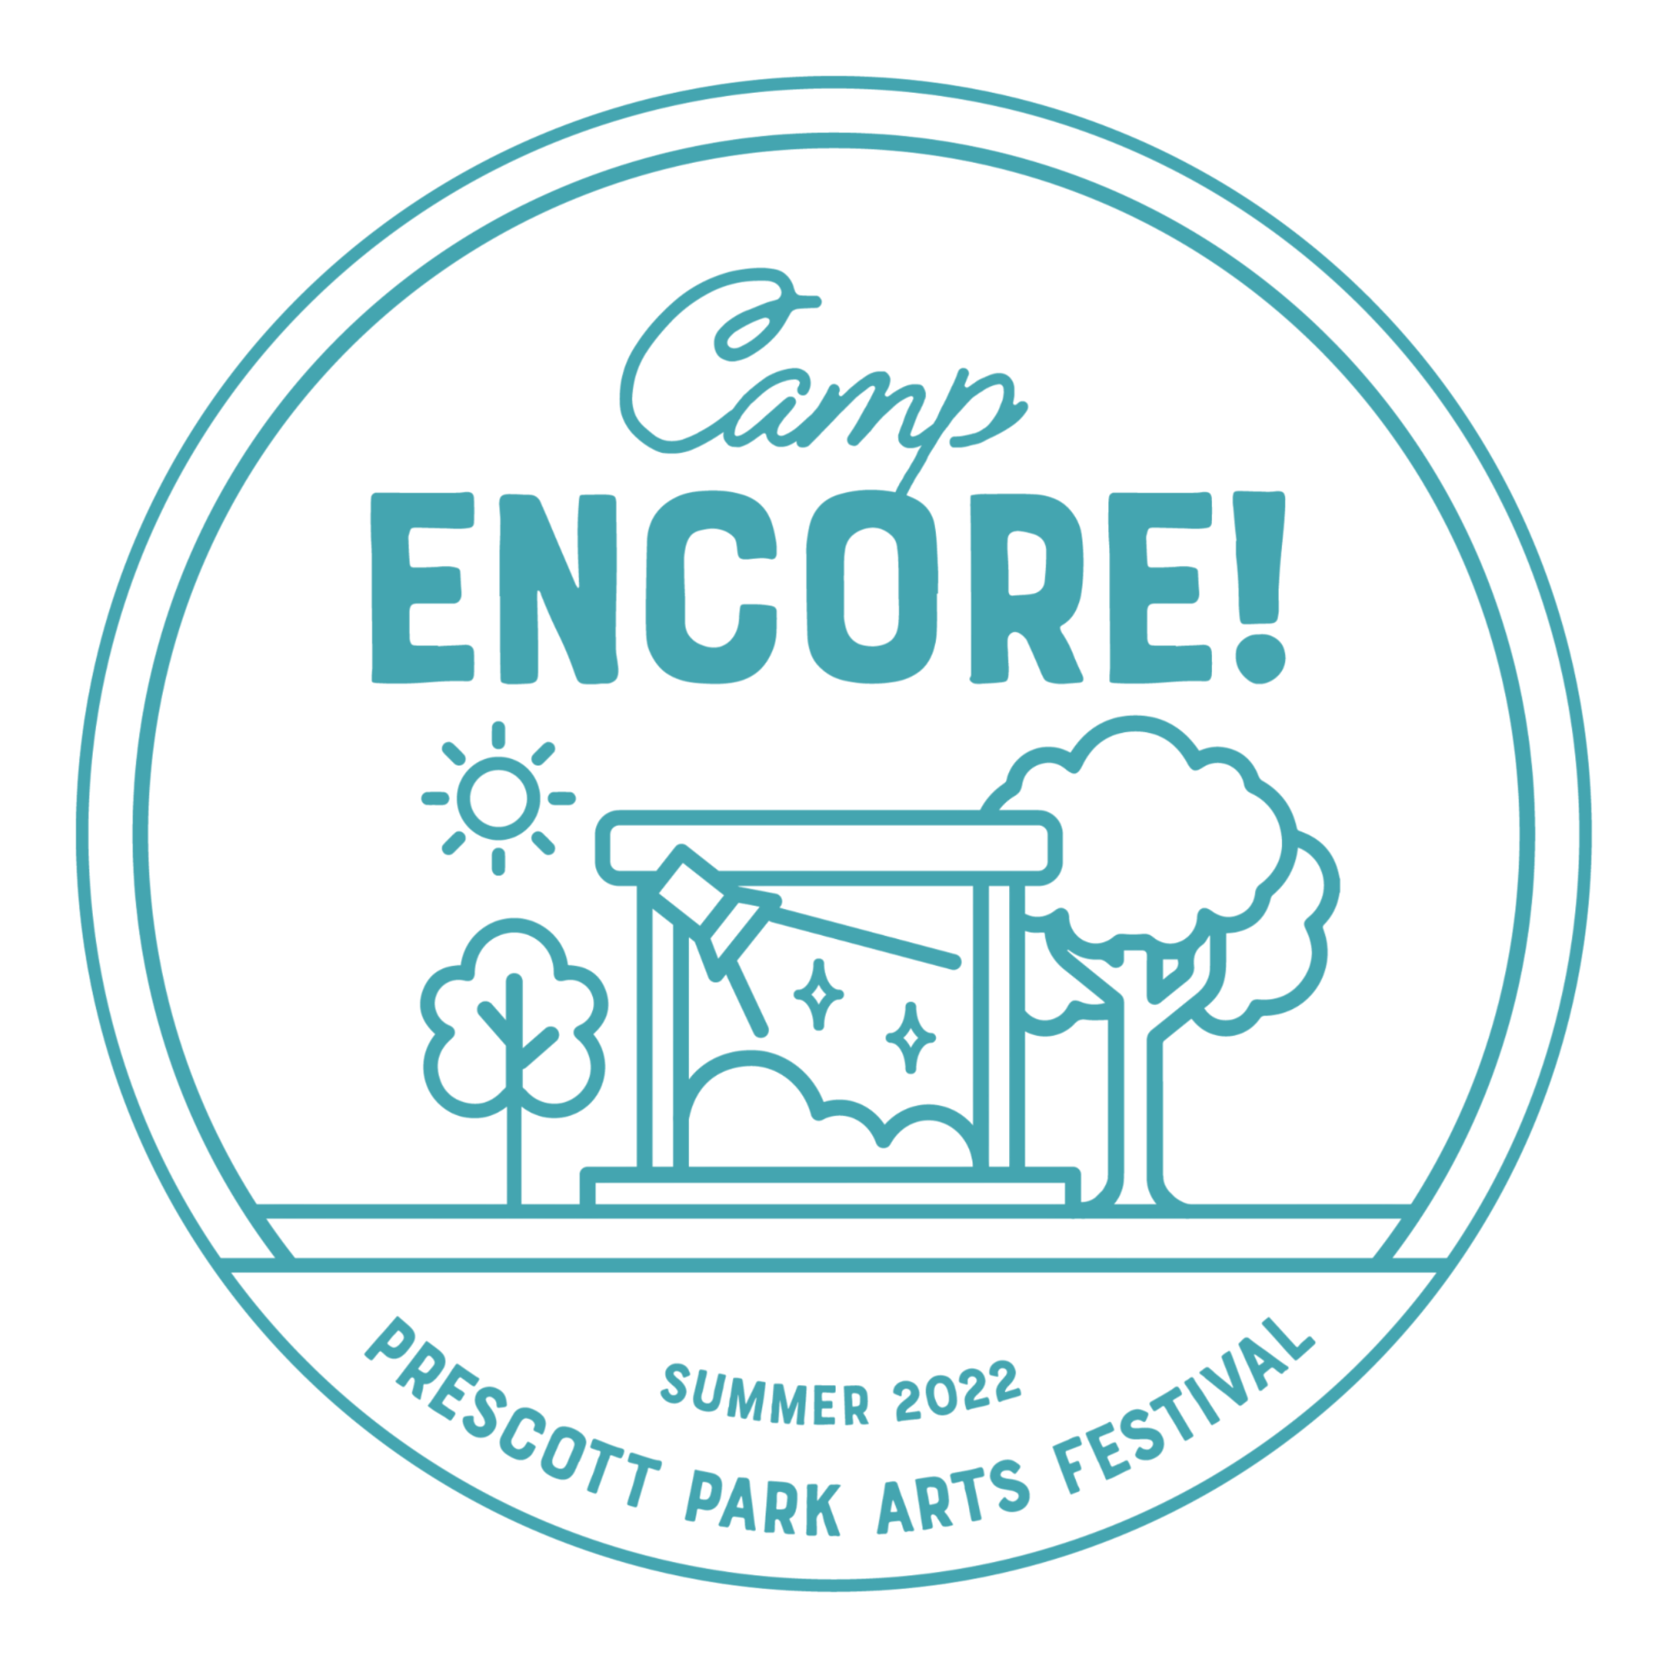
Camp Encore Scholarship Application Information

Scholarship Application Packages are due by May 1st
Scholarships will be awarded by May 15.
There are 3 documents required to complete your application package:

Step 1: Online Application
To be completed by parent or guardian. Click here to complete.

Step 2: Camper Questionnaire
To be completed by the camper: Click here to complete. Scan and email it to us at camp@prescottpark.org or mail it to the address below.

Step 3: Letter of Recommendation
Have your camper ask for a 'Letter of Recommendation' from a teacher (classroom or specialty, such as voice or dance) or a director. This letter should address the camper's ability, desire to learn, and potential. Your camper doesn’t have to have a specialty, but we do want to ensure that they love to learn!

Once completed, they may scan and email it to us at camp@prescottpark.org or mail it to:
Camp ENCORE!
P.O. Box 4370
Portsmouth, NH 03802

Income Requirements
Family Size Maximum Gross Income to Qualify

2 | $34,840
3 | $43,920
4 | $53,000
5 | $62,080
6 | $71,160
7 | $80,240
8 | $89,320

